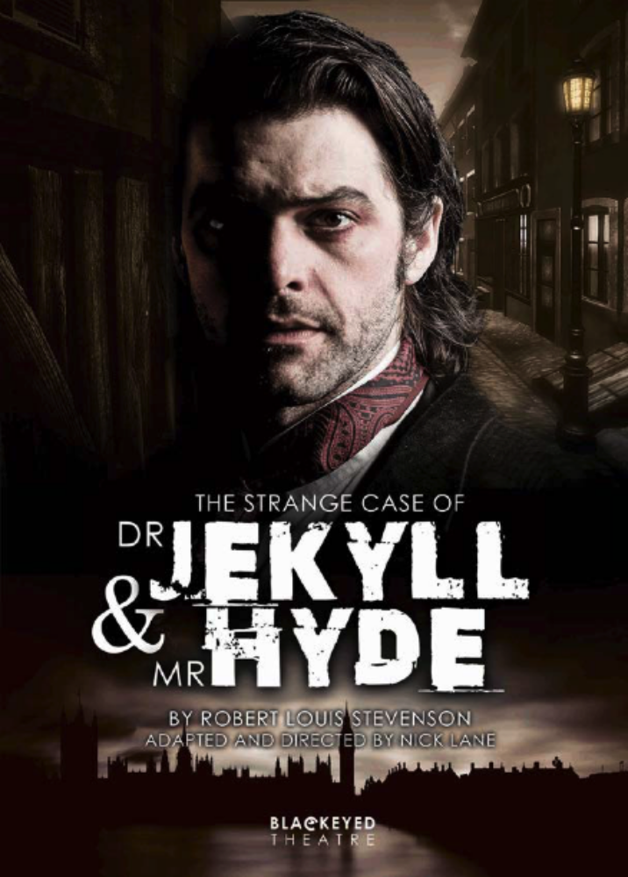

Media Pack

Blackeyed Theatre  www.blackeyedtheatre.co.uk  adrian@blackeyedtheatre.co.uk  07766 681943  01344 530924

Contents

Credits 3

Press release 4

Tour dates – Autumn 2017 5

Tour dates – Spring 2018 7

Box office Information 9

Cast 10

Nick Lane 13

Selling Points 14

Press Quotes 15

The History of Jekyll & Hyde 16

Robert Louis Stevenson 17

The Adaptation 18

Interview with the Writer/Director 19

Cast Interviews 22

Artistic Team Biographies 25

Blackeyed Theatre 28

Images / Online Media / Contact details 29

Credits

The Strange Case of Dr Jekyll & Mr Hyde
By Robert Louis Stevenson
Adapted by Nick Lane

Produced by Blackeyed Theatre
in association with South Hill Park Arts Centre

Cast

Dr Jekyll / Mr Hyde Jack Bannell
Gabriel Utterson Zach Lee
Eleanor Lanyon Paige Round
Hastings Lanyon Ashley Sean-Cook

All other parts played by members of the cast

Artistic Team

Writer & Director Nick Lane
Composer Tristan Parkes
Set Designer Victoria Spearing
Lighting Designer Claire Childs
Costume Designer Naomi Gibbs
Producer Adrian McDougall
Press Relations Chloe Nelkin Consulting
Press Release

Blackeyed Theatre, in association with South Hill Park, presents

The Strange Case of Dr Jekyll & Mr Hyde
By Robert Louis Stevenson. Adapted by Nick Lane

UK Tour Autumn 2017 – Spring 2018
Press Night: Wednesday 4 October, 7.30pm, Greenwich Theatre

This September, a thrilling new adaptation of Robert Louis Stevenson’s dark psychological fantasy, The Strange Case of Dr Jekyll and Mr Hyde, will be embarking on a five-month UK tour, immersing audiences in the myth and mystery of 19th century London. The production, which is adapted and directed by Nick Lane, presents a unique take on the classic Gothic horror story.

Doctor Henry Jekyll is a good man. Successful within his field and respected by his peers, he’s close to a neurological discovery that will change the face of medical science forever. However, his methods are less than ethical and when a close friend and colleague threatens to expose and destroy his work, Jekyll is forced to experiment on himself, whereupon something goes very wrong...or very right. Suddenly Jekyll has a new friend, the brutal Edward Hyde.

This gripping production takes inspiration from Lane’s own personal journey. Injured by a car accident at the age of 26 that permanently damaged his neck and back, Lane imagines Jekyll as a physically weakened man who discovers a cure for his ailments, a cure that also unearths the darkest corners of his psyche. Lane says, “I wondered, if someone offered me a potion that was guaranteed to make me feel the way I did before the accident, but with the side effect that I’d become ruthless and horrible – would I drink it?”

Combining ensemble story-telling, physical theatre, movement and Lane’s razor-sharp script, alongside a new musical score by Tristan Parkes, The Strange Case of Dr Jekyll & Mr Hyde remains true to the spirit and themes of the original novella while offering modern audiences one or two surprises, including a major female character, Eleanor, who drives Jekyll on in the same way Stevenson’s wife urged her husband to complete the novel.

Lane, who was Associate Director and Literary Manager at Hull Truck from 2006 to 2014, comments, “I'm incredibly excited to be working with Blackeyed Theatre on The Strange Case of Dr. Jekyll & Mr. Hyde. To be given the opportunity to revisit a book that I love and adapt it for four terrific actors is an absolute gift for me, and I couldn't think of a better venue to launch the tour than the Wilde Theatre. I hope people book their seats, and then spend the entire show on the edge of them!”

The cast includes Jack Bannell as Henry Jekyll/Edward Hyde (The Comedy of Errors, Tobacco Factory; Antony and Cleopatra, Chichester Festival Theatre; Beggar’s Opera, Regent’s Park), Paige Round as Eleanor Lanyon (Hurling Rubble at the Moon, Park Theatre; Nobody, Hanyong Theatre/National Theatre Company of Korea), Zach Lee as Gabriel Utterson (Bouncers, Glass Menagerie, Hull Truck; The Derby McQueen Affair, York Theatre Royal; Treasure Island, Harrogate Theatre) and Ashley Sean-Cook as Hastings Lanyon (Frankenstein, Blackeyed Theatre; Might Never Happen, King’s Head).

Ends
Tour Dates – Autumn 2017

Date | Theatre | Town / City
Sept 20 - 22 | Wilde Theatre  7.45pm (+2pm Thu) | Bracknell
Sept 25 | EM Forster Theatre  7.30pm | Tonbridge
Sept 26 - 27 | Theatre Royal  7.30pm (+2pm Wed) | Bury St Edmunds
Sept 29 | Auden Theatre  7.30pm | Holt
Oct 3 | The Haymarket  2pm & 7.30pm | Basingstoke
Oct 4 - 7 | Greenwich Theatre  7.30pm (+2.30pm Thu & Sat) | Greenwich
Oct 9 - 10 | Norwich Playhouse  7.30pm (+1pm Tue) | Norwich
Oct 12 - 13 | Waterside Arts Centre  7.30pm (+1.30pm Fri) | Sale
Oct 14 | The Atkinson  7.30pm | Southport
Oct 17 - 19 | Devonshire Park Theatre  7.45pm (+2.30pm Wed) | Eastbourne
Oct 20 | Roses Theatre  7.30pm | Tewkesbury
Oct 24 | Queen's Hall Arts Centre  7.30pm | Hexham
Oct 26 | Adam Smith Theatre  7.30pm | Kirkcaldy
Oct 27 | Gaiety Theatre  7.30pm | Ayr
Oct 28 | The Brunton  7.30pm | Musselburgh
Oct 30 | Eastwood Park Theatre  7.30pm | Giffnock
Nov 1 | The Majestic Theatre  7.30pm | Darlington
Nov 2 | Kings Theatre  2pm | York
Nov 7 | The Lights  7.30pm | Andover
Nov 8 | Cornerstone  7.30pm | Didcot
Nov 9 | New Theatre Royal  7.30pm | Portsmouth
Nov 10 | The Berry Theatre  7.30pm | Hedge End
Nov 13 - 14 | Garrick Theatre  7.30pm | Lichfield
Nov 15 - 17 | Arena Theatre  7.30pm (+1pm Fri) | Wolverhampton
Nov 20 | Stahl Theatre  7.45pm | Oundle
Nov 21 - 22 | Stantonbury Theatre  7.30pm | Milton-Keynes
Nov 23 | Lincoln Performing Arts Centre  7.30pm | Lincoln
Nov 24 | Bridge House Theatre  7.30pm | Warwick
Nov 27 - 29 | Mumford Theatre  7.30pm | Cambridge

Tour Dates – Spring 2018

Date | Theatre | Town / City
Jan 23 | The Haymarket  7.30pm | Basingstoke
Jan 24 | White Rock Theatre  7.30pm | Hastings
Jan 25 | Capitol Theatre  7.30pm | Horsham
Jan 26 | Trinity Theatre  8pm | Tunbridge Wells
Jan 30 | Key Theatre  7.30pm | Peterborough
Jan 31 - Feb 1 | Towngate Theatre  7.30pm (2.30pm Tue) | Basildon
Feb 2 | The Woodville  7.30pm | Gravesend
Feb 6 | Marina Theatre  2.30pm & 7.30pm | Lowestoft
Feb 7 | Gulbenkian Theatre  7.30pm | Canterbury
Feb 8 | Theatre Royal  7.30pm | Margate
Feb 9 | Broadway Theatre  7.30pm | Barking
Feb 12 - 13 | Civic Theatre  7.30pm | Rotherham
Feb 14 - 16 | Theatre Severn  7.30pm (+2.30pm Thu) | Shrewsbury
Feb 20 - 21 | Venue Cymru  Tue 7.30pm / Wed 2.30pm | Llandudno
Feb 22 - 23 | Charter Theatre  7.30pm (+1.30pm Fri) | Preston
Feb 26 | Grand Theatre  7.30pm | Lancaster
Feb 27/28 | Brewery Arts Centre  8pm | Kendal
Mar 1 | Theatre Royal  7.30pm | Wakefield
Mar 3 | Square Chapel  2 & 7.30pm | Halifax
Mar 6 - 7 | Lighthouse  7.45pm | Poole
Mar 8 | The Maltings  7.30pm | Farnham
Mar 9 | Sandpit Theatre  7.30pm | St Albans
Mar 12 | Arts At Stowe  8pm | Stowe
Mar 13 | Town Hall Theatre  7.30pm | Loughborough
Mar 14 - 15 | Harrogate Theatre  Times TBC | Harrogate
Mar 16 | Middlesbrough Theatre  7.30pm | Middlesbrough
Mar 20 | Riverfront  7.30pm | Newport
Mar 21 | Brewhouse Theatre  7.30pm | Taunton
Mar 23 | Swan Theatre  7.30pm | Worcester
Mar 24 | Theatr Brycheiniog  7.30pm | Brecon
Box Office Information

Title | The Strange Case of Dr Jekyll & Mr Hyde
Author | Adapted from Robert Louis Stevenson’s novel by Nick Lane
Company | Blackeyed Theatre - www.blackeyedtheatre.co.uk
Running time | Approx 120 minutes including interval
Type of event | Play
Style of work | Innovative, high energy theatre using ensemble storytelling set against an atmospheric soundscape.
Description | A thrilling adaptation of Robert Louis Stevenson’s dark psychological fantasy, The Strange Case of Dr Jekyll And Mr Hyde immerses you in the myth and mystery of 19th century London’s fog-bound streets where love, betrayal and murder lurk at every chilling twist and turn. Gripping, stylish and thought-provoking, this is unmissable theatre.
Warnings | None
Age suitability | 11+
Number of performers | 4
Additional activities | Post-show Q&As may be available. Please check with venue.  Schools workshops available. Contact company for details.  Education pack available from www.blackeyedtheatre.co.uk

Cast

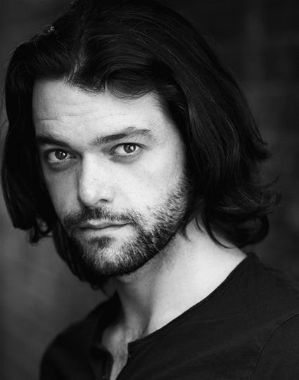 | Jack Bannell - Henry Jekyll / Edward Hyde  Jack trained at Bristol Old Vic Theatre School.  His theatre credits include Oberon in A Midsummer Night's Dream (Watch Your Head), Valentine in Two Gentlemen of Verona, Dr Pinch in The Comedy of Errors, Henry Percy in Richard II and Richmond in Richard III (Tobacco Factory), Proculeius in Antony And Cleopatra (Chichester Festival Theatre), Demetrius in A Midsummer Night's Dream and Slender in The Merry Wives of Windsor (Guildford Shakespeare Company), Ben Budge in Beggar's Opera (Regents Park), John Proctor in The Crucible (Bristol Old Vic) & Don John in Much Ado About Nothing (Vienna's English Theatre).  His television credits include Franklin in Upstairs Downstairs (BBC).
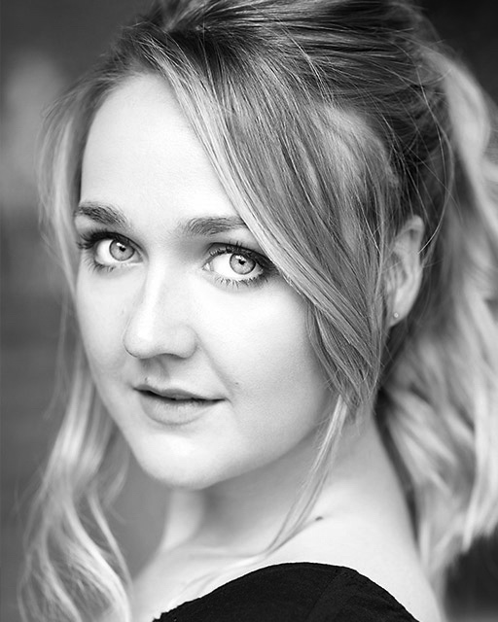 | Paige Round – Eleanor Lanyon  Paige trained at Royal Central School of Speech and Drama.  Her credits include Gerbil in the world premiere of Hurling Rubble at the Moon by Avaes Mohammad (Park Theatre), Ensemble in Pink Floyd -The Wall (workshop) The Messenger in Antigone (Belsize Park Festival), Grenthel in Jack and the Beanstalk (Park Theatre), Helena in A Midsummer Night’s Dream (Watch Your Head) Girl in Nobody (Hanyong Theatre/National Theatre Company of Korea)  Credits whilst training include: Rizzo in Grease, Gertrude in Hamlet, Amy in Company, Masha in Three Sisters and Madame Gloumova in Too Clever By Half.

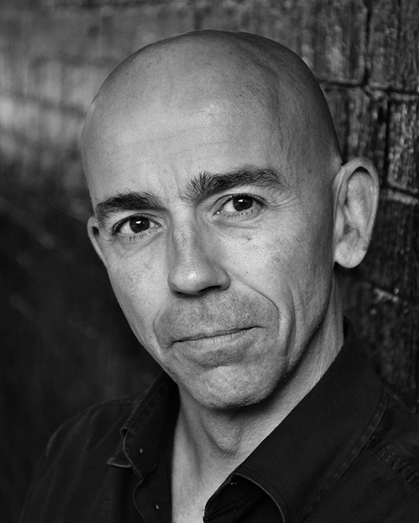 | Zach Lee – Gabriel Utterson  Zach trained at The Arts Educational School a long time ago!  His recent work in theatre includes Bouncers, A Weekend In England, Glass Menagerie, Dr Faustus, Frankenstein, Wuthering Heights, Little Malcolm And His Struggle Against The Eunochs, A Christmas Carol, Unleashed and Reunion, for which he received a nomination for Best Actor at the 2003 Manchester Evening News Awards (all Hull Truck), The Derby McQueen Affair (York Theatre Royal), Round The Twist (Eastern Angles), The Winters Tale (Nulty/Pilton Productions), Treasure Island (Harrogate Theatre), South (Shred Productions), Five Kinds of Silence (Stepping Out Theatre), The Wife (Rude Mechanicals), Romeo & Juliet, 100, Some Voices (Alchemy Theatre Co), Moby Dick and Frankenstein: Revelations  (Theatre Mill) and Monopoleyes (Stolen Thread). He has written & produced two plays, Geoffrey Ramsbottom - Man of the 90s (Tabard Theatre) and Two Brothers And One World Cup  (Underbelly, Edinburgh Festival then UK Tour).  His television credits include Emmerdale, Coronation Street, Crime Traveller, Class Act (ITV), Young Dracula (CBBC), In The Club (BBC), The Contract, Sickness And Health, Feelgood Factor (CH4), both series of Lynda La Plante's The Governor (ITV) and Underbelly (CH 9 Australia).  His feature Films include Chasing Dreams, Hard Edge (DMS Films), Mortal Fools (Virtual World Productions) and The Creature Below (Dark Rift Films).  Zach is a Fingerstyle guitar player and his YouTube Channel “Zach Lee Guitar” shows him playing a wide range of arrangements including Classical, Jazz, Spanish, Pop and Blues.

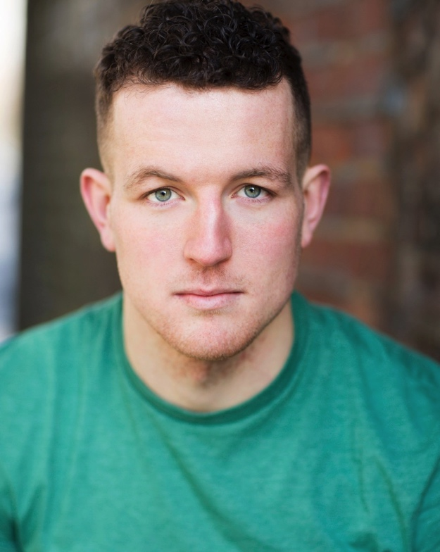 | Ashley Sean-Cook – Hastings Lanyon  Ashley graduated from the BA Acting course at Northampton School of the Arts in 2014.  His theatre credits include Frankenstein (Blackeyed Theatre), Might Never Happen (Doll's Eye Theatre Company at the Kings Head), The Boy in the Striped Pyjamas (Children's Touring Partnership), Little Victorians, World War One, Shakespeare at Night (Phileas Fogg Theatre), My Pet Monster and Me and The Duck in the Truck (Blunderbus Theatre Company UK tours).  Ashley has developed a huge passion for puppetry since graduating and produced and directed his own show, Sell-By-Date, which has toured various fringe venues.

Nick Lane

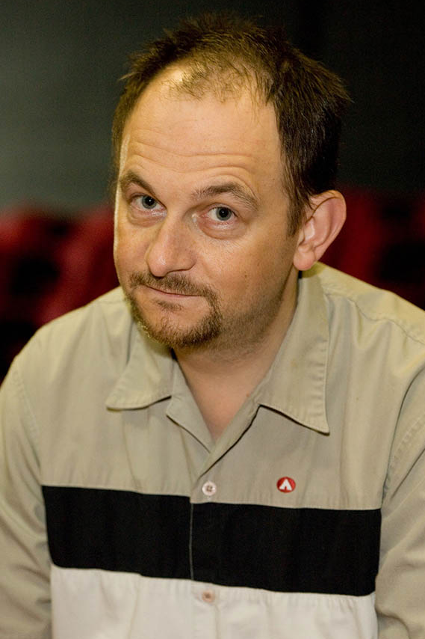 | Nick started his career as an actor until a car accident damaged his back and brought his acting career to a premature end. After that he turned to writing and directing. From 2006-2014 he was the Associate Director and Literary Manager of Hull Truck Theatre, a company with which he has had a long association.  Nick has adapted The Strange Case of Dr. Jekyll & Mr Hyde (Hull Truck/Theatre Mill) named one of the twelve best regional theatre productions in the UK 2015. Other adaptations include The Wakefield Mysteries (Theatre Royal Wakefield), Frankenstein, Lady Chatterley’s Lover (Hull Truck) and 1984 (Northern Broadsides), as well as a co-adaptation of Moby Dick for Hull Truck with his friend John Godber. Original adult plays include: The Derby McQueen Affair (York Theatre Royal), My Favourite Summer (Hull Truck), Blue Cross Xmas (Hull Truck), Me & Me Dad (Hull Truck), Housebound (Reform), Seconds Out (Reform), Royal Flush and Odd Job Men (Rich Seam Theatre).  Nick is also an accomplished children’s playwright – his credits include: A Christmas Carol, Beauty & The Beast, The Hunchback of Notre Dame and The Snow Queen (Hull Truck); Pinocchio (SJT); Snow White and Little Red Riding Hood (York Theatre Royal); The Elves & The Shoemaker (Hereford Courtyard); and Hansel & Gretel (Pilot). His original work for children includes the acclaimed Ginger Jones and the Sultan’s Eye (Polka/ Drum Theatre Plymouth/ York Theatre Royal), ‘Twas The Night Before Christmas, When Santa Got Stuck in the Fridge and A Christmas Fairytale (Hull Truck).  Plays that Nick has directed include The Glass Menagerie, Departures, Life’s A Beach, Studs, Beef, Amateur Girl, Lucky Sods and Ring Around the Humber (Hull Truck), April in Paris, Two, September in the Rain and Little Italy (York Theatre Royal).
‘Selling Points’

Below are a few notable facts about the production

The Strange Case of Dr Jekyll and Mr Hyde is a gothic novella by the Scottish author, Robert Louis Stevenson, first published in 1886. It is about a London lawyer named Gabriel John Utterson who investigates strange occurrences between his old friend, Dr Henry Jekyll, and the evil Edward Hyde. The novella's impact is such that it has become a part of the language, with the very phrase "Jekyll and Hyde" coming to mean a person who is vastly different in moral character from one situation to the next.

The story of Jekyll & Hyde has become one of the most famous in the English language and has been adapted more than120 times for stage and screen.

Nick Lane first adapted The Strange case of Dr Jekyll & Mr Hyde in 2012 for Hull Truck Theatre, where he was Associate Director and Literary Manager from 2006 to 2014. For this production, Nick Lane has rewritten that version, increasing the cast from three to four.

Nick Lane took inspiration for this adaptation from his own life circumstances. When he was 26, he was involved in a car accident, which left him physically debilitated. This inspired him to write Dr Jekyll as a physically impaired man seeking a cure through neuro-science. However, the cure he discovers also unearths the darkest part of his psyche.

A notable feature of this adaptation is the addition of a major female character, Eleanor Lanyon, who doesn’t appear in the original story. The inclusion of a strong female character is important to Blackeyed Theatre’s aims to be relevant to modern audiences and engage young people. The inclusion of Eleanor also enhances the themes and dramatic potential of the play.

The Strange Case of Dr Jekyll & Mr Hyde is recommended and prescribed reading for GCSE English literature by AQA, OCR and Edexcel examination boards. It has become one of the most analysed literary texts of the modern age.

Blackeyed Theatre’s tour of The Strange Case of Dr Jekyll & Mr Hyde will visit more than 60 theatres across England, Wales and Scotland.

Press Quotes

“A thrillingly dark drama” The Stage (the original adaptation)

“A finely crafted adaptation that will keep you fastened to your seat” British Theatre Guide (The original adaptation)

“A writer who knows what he’s doing” The Guardian

“Lane explores the scientific ideas of the day and the development of neuroscience without it feeling like a foundation lecture in 'A' level psychology” The Independent

About Blackeyed Theatre:

“One of the most innovative, audacious companies working in contemporary English Theatre” The Stage

★★★★★
“Masterful” Broadsheet Boutique (Frankenstein 2017)

★★★★
“Mary Shelley would have loved it” Daily Express (Frankenstein 2017)

“Masterfully constructed” The Stage (Frankenstein 2017)

★★★★
“Rewardingly rich entertainment” The Upcoming (The Great Gatsby 2016)

★★★★★
“Timeless” Reviews Hub (Teechers 2015)

★★★★
“Exhaustingly emotive” The Stage (Not About Heroes 2014)

★★★★
“Great clarity and theatrical ingenuity” What’s On Stage (Dracula 2013)
The History of Jekyll & Hyde

Published in 1886, The Strange Case of Dr Jekyll and Mr Hyde (originally published as Strange Case of Dr Jekyll & Mr Hyde) has established itself as an enduring tale. It remains in our cultural psyche to the extent that the revelation that Jekyll and Hyde are one and the same – opposing aspects of the same man – is a fact well known even to those who have never read Stevenson’s book. The phrase ‘Jekyll and Hyde’ has even become part of our everyday language, defined as a person who displays alternate morally good and evil personalities; who is able to create and manipulate their own moral universe. This revelation of the characters duality therefore cannot have the same impact in a modern adaptation as it had in the original novel - the play accepts that Jekyll and Hyde are one and that the audience will not be shocked by this fact.

The Strange Case of Dr Jekyll and Mr Hyde was an immediate success and the first stage adaptation took place within a year of publication. There are over 100 film versions, a musical stage version, radio and stage plays and songs in numerous languages. The characters of Jekyll and Hyde have also been used within other narratives, for example Mary Reilly (the 1996 movie starring John Malkovich and Julia Roberts). A variation of the Jekyll and Hyde theme can also be seen in coming of age body swap films such as Freaky Friday (2003,Jamie Lee Curtis and Lindsay Lohan). Further explorations of split personality, ranging from the Marvel Superhero character The Hulk (otherwise known as Dr. Bruce Banner), or Jeff Goldblum’s character Dr. Seth Brundle in David Cronenberg’s 1986 adaptation of The Fly, right through to the central character of Tyler Durden in Chuck Palahniuk’s novel Fight Club, owe a great debt to Stevenson’s central figure. Many adaptations of The Strange Case of Dr Jekyll and Mr Hyde omit the character of Utterson, the narrator of the novel - who does feature in Nick Lane’s adaptation. The majority of adaptations have added a love interest that does not feature in the book. By having the main characters of Jekyll and Hyde played by the same actor, the mystery of Jekyll and Hyde’s dual identity is no longer the revelation at the heart of the novel.

Themes within the novel continue to fascinate modern audiences. The nature of man and the combination of good and evil nature within the human soul have consistently engrossed readers since the book’s publication 131 years ago.

Robert Louis Stevenson

Robert Louis Stevenson (1850 – 1894) is best remembered as the author of The Strange Case of Dr Jekyll and Mr Hyde (1886) and Treasure Island (1883).

Stevenson was plagued by ill health throughout his life. This did not stop him travelling extensively, throughout Europe, North America and the Pacific. Born in Scotland, at the time of his death Stevenson was living in Samoa.

Stevenson was born into smothering conformity and raised a Calvinist. This left him with a fascination with pre-determination and man’s ability to shape his own destiny, which he explored within Jekyll and Hyde. We also see parallels between the suffocating expectations placed on the men of standing within Jekyll and Hyde and what was expected of Stevenson as a young man. Stevenson did not adhere to these expectations, choosing travel and a literary career above the engineering work of his forbearers.

Stevenson’s wife was at once his greatest supporter and harshest critic. The first draft of the piece, which allegedly took Stevenson around three days to write, was burned by the author after his wife claimed she felt the piece was too allegorical. Stevenson wanted to write a story, not create an allegorical account (where characters represent a certain theme or concept). The final frantic re-write took Stevenson between three and six days to complete, during which time he was sick and bed ridden. It is disputed as to whether Stevenson was using drugs heavily at the time of writing, which may have impacted upon the story.

The Adaptation

Adaptation from novels is a popular method of creating new theatre. A new approach to a popular novel can allow those familiar with the work to enjoy it in a new medium and attract new audiences. Playwrights are able to add their own interpretation, shed new light on characters, often increasing the audience’s knowledge of minor characters and exploring existing themes in a new way. Adaptations will often modernise a classic tale, changing key details to appeal to new audiences, for instance setting the tale within a different era as many adaptations of Shakespeare’s work have successfully done.

Nick Lane’s decision to keep his Jekyll and Hyde in the late nineteenth century was a pragmatic one. “I felt that the 1890’s were perfect as the advent of neuroscience at that time fitted in with the medical and philanthropic angle I wanted to approach Dr Jekyll’s work from.”

Some of the key differences between Nick Lane’s adaptation and Stevenson’s original include the exploration of minor characters as well as looking into why and how Dr. Jekyll reaches the point at which he is prepared to transform into Hyde. The breakdown of the friendship between Jekyll and Lanyon is explored extensively within the play and the character of Lanyon developed into a far more complicated man than within Stevenson’s novel.

Another key addition comes in the character of Eleanor, who provides a spur for Jekyll, pushing him on in much the same way as Stevenson’s wife urged her husband to complete the novel. The complexity added by the fact that Eleanor is engaged to someone else when she meets Jekyll is what provides the play with its doomed romantic angle. The character of Eleanor allows the audience to see Jekyll as a man rather than purely a scientist. She is a witness to much of the detail of Jekyll and Hyde’s secret, which in the novel is only discovered following Hyde’s demise. Scenes such as Hyde burning the chequebook after murdering the MP Sir Danvers Carew are given an additional dimension by Eleanor’s presence. In the novel this goes unseen.

In addition, Eleanor delivers Jekyll’s research to Utterson following the doctor’s death. This is quite a departure from the abrupt ending of the novel, in which – since the doctor’s work is purely selfish – only Jekyll’s confession is delivered to the lawyer. Here the idea is that the story of Jekyll and Hyde may continue, if Utterson finds a medical student capable enough to use what Jekyll has uncovered in the right way. Further, the child that Hyde has given Eleanor is an added complication, touching on themes of nature versus nurture.

Nick Lane comments that “the themes and title of Jekyll and Hyde are perhaps far more enduring and well known than the story itself. It’s a great piece to adapt from because there is the freedom to be creative and include new ideas within a very successful and structured narrative which Stevenson has provided.”

There are parts of the play where the book is quoted directly (Enfield’s retelling of the story of the door is a good example). The non-chronological telling of the story is also seen within both the play (where characters recount past events) and the novel (where the story is revealed to Utterson in letters from Dr’s Lanyon and Jekyll after their deaths).

Interview with Writer and Director, Nick Lane

Tell us about your new production of The Strange Case of Dr Jekyll and Mr Hyde...

Well, it’s a small/mid-scale tour of an adaptation of Robert Louis Stevenson’s classic horror story but I’ve tried to put a twist on it. I was aware approaching the adaptation that people have certain preconceptions about the story, and I thought it might be fun to come up with something a bit different.
What inspired you to tackle this story?

I think the story itself, the original tale; it’s just brilliant. And after that, with the other adaptations that I’ve done, what’s always helped me to get into a story is finding a personal angle – in terms of Jekyll & Hyde, what intrigued me was looking at what the consequences would be if Jekyll was incredibly intelligent but physically weak, and Hyde was a really powerful man, albeit very cruel.

Some years ago I was in a car accident that permanently damaged my neck and back. I wondered, if someone offered me a potion that was guaranteed to make me feel the way I did before the accident, but with the side effect that I’d become ruthless and horrible – would I drink it? Would I make that trade? If I knew I could do it for a day then I suppose I might, but what if the feeling of being strong and healthy became an addiction?

It’s Pandora’s Box. You know the risks of something but would you do it? A butterfly wouldn’t want to become a caterpillar again because once it has wings it wants to fly. That’s the difference, as soon as you make Hyde the strong one, I wonder if he’d want to go back to being weak old Jekyll again. So it’s a question of “does the body rule the mind, or does the mind rule the body?”
What’s different about this production?

I suppose if you were to describe the original novel as a traditional horror story, this is an attempt to find a new way to scare the audience. It’s a small cast, so I’ve tried to ramp up the physicality, the claustrophobia and the menace. And ultimately I’d like the audience to go home with the questions facing Jekyll racing around in their minds.
How have you approached this adaptation?

Jekyll is a medical man, so I’ve gone down the route of looking at why Jekyll is exploring the ability to split the mind. In the book, Jekyll is just fascinated by his own nature; he wants to look at why good is good and evil is evil within him. What I wondered was, what if Jekyll was looking at splitting the mind to perhaps find a cure for schizophrenia or any other mental disorder? You have to remain true to the source material and in particular the spirit, themes and drive that the author of the source material wants to explore. Beyond that, I guess you look for opportunities within the text to explore other things, and I find that question of research versus morality fascinating.

You’ve been keen to set the book in the era it was originally written in. Was that a conscious decision or did you not want to make a modern adaptation?

I think the themes are strong enough to transcend any particular period so I thought it was natural to stay faithful to Stevenson’s vision. There is a slight shift – Stevenson wrote the book in the 1880s, but doesn’t specify what years of the 19th century the story covers. This play is set in the 1890s, simply because at that time a lot of interesting historical events which I felt I could draw on were taking place. That particular era was also regarded by many as the birth of modern neuroscience so I’ve placed Jekyll amongst genuine experts in that field, as if he too were a pioneer – albeit a very twisted one with results that were more than he bargained for.

You mentioned you were keen to look at the back-story. What challenges does this bring to you as a writer?

Initially it’s down to the research and ensuring the story you’ve made is consistent. The book edition of Jekyll and Hyde that I have is only 48 pages long, although the print is very small! The original idea is absolutely brilliant, and at the time must have been chilling, but for a modern audience who aren’t surprised by the revelation that Jekyll and Hyde are one and the same, you have to work that bit harder to find something that might shock. Finding a good back-story actually presented me with a great opportunity to embellish the original text and add something that I hope Stevenson would approve of.

Within this production Jekyll and Hyde we see a lot of multi rolling – (sixteen characters are played by a cast of four). What made you decide to tell the story theatrically with a cast of just four?

It’s been my practice, my stock in trade, and Blackeyed Theatre has a tradition of telling stories with smaller casts. With a story like this it works really well. In the book Jekyll and Hyde are described as two different people, but generally adaptations have the same actor playing them.

There are stories you can’t tell with a small cast. I was given the option of what I wanted to adapt knowing the cast would be this size, so you have to find ways to tell those stories. I thought it would be nice to look at this story from a medical and philanthropic angle and to use multi-roling to our advantage because Jekyll and Hyde is the original multirole.

As a director how do you approach multi-roling with your actors?

There are lots of techniques, but the secret, if there is one, is to cast the right people who you know have got that skill. This piece is interesting as two actors play the same character, so we’ll have fun looking at gestures and vocal tone and body language.

I come at it from the point of view that if the words are there and actors are talented enough, I would rather give actors opportunity to explore and discover themselves what different characters are and we can discuss it. That gives actors ownership, rather than arriving with my preconceived ideas of what character are and make the actors conform to the way I work.

I approach it the way I would with a ‘one actor, one character’ play, which is to empower actors enough to feel strong enough to come to their own conclusions.

How important to this adaptation is the character of Eleanor and where did you draw inspiration for her character from?

I think all the characters are important, they lend focus to the wider narrative which I have decided to craft on. The novel doesn’t have a character called Eleanor; the women in the novel seem very functional at best. Stevenson was writing for a man’s world, his novels are very male dominated. Yet one of the biggest inspirations and motivators for his work was his wife. She pushed him to create; she was his harshest critic, his fiercest editor and his most strident advocate. I think that that’s in part where I got Eleanor from. Her character serves as a catalyst. She gives him a reason to continue.

There’s also Annie who is a prostitute character, who is very important for her socio political positioning. Eleanor is an Irish immigrant, so she is from the working classes, like Annie. We meet Eleanor, but she is outside her own class so we can use her as our eyes onto that world. Annie is still within the working classes. So for Eleanor, Annie is an example of ‘there but for the grace of God’ – had Eleanor made different choices, this is where she could have ended up. In terms of giving context to who Eleanor is, it’s really important to have Annie there.

Victorian society was deeply entrenched with the class system and lines were recognisably drawn. To have a working class character enter into that world, gives the audience a sense of that division.

In what ways do you hope this adaptation will appeal to a modern audience?

There will be physical theatre, movement and dance. There’s a new score being written by Tristan Parkes, who is a fantastic composer. And then four fantastic actors.

The first adaptation for stage took place less than a year after publication and 131 years later, the novel is still inspiring theatrical performances. What is it about the story that lends itself well to theatrical staging?

It’s a book with a number of very strong themes and a gripping mystery. There is room to put different characters in there. It’s a fun story to create onstage, because you can explode it. You can add to it while staying true to Stevenson’s narrative. I’m interested in why people do the things they do and the greying of morality. I enjoy creating well-rounded characters. For example Lanyon, in order to give a scale of morality. Utterson is black and white, the law. Jekyll is the greying morality – very morally flexible, Hyde creates his own moral universe and does as he wants. Lanyon is heart and conscience. And Eleanor is drawn to Jekyll and Hyde because for a certain type of person, sometimes good, moral people like Lanyon can be perceived as dull.

Another thing I wanted to do was look at a different reason behind why Jekyll is so insistent on pursuing this particular line of research. I think that’s why the story has persevered. It gives writers scope and opportunity to play and explore with a really strong narrative core.

Cast Interviews

Jack Bannell
What are you looking forward to most about The Strange Case of Dr Jekyll & Mr Hyde?
The complexity of the character without a doubt. Every part I have ever played has been an exercise in finding the duality and inner struggle of a character. To have two conflicting emotions about the same thing is what it means to be a complicated emotional human, It's what makes Humans so unpredictable and fascinating, and hopefully lead to dramatic choices that are not the obvious, predictable ones to make; however, rarely do you get the opportunity to take those dual emotions and polarize them into two different "people"... Or are they different people?

You’ll be playing the dual role of Jekyll/Hyde in this production. How do you approach creating characters that audiences are so familiar with?
Personally I think the only way to approach a well-known character is to pretend they are not well known. Much like approaching a well-known Shakespeare monologue, If you let the gravity of "to be or not to be" or "I know a bank where the wild time blows" get to you, you can double guess yourself, over complicate everything and end up in a right mess. All characters are a person, in a situation, trying to achieve something...if they are famous or not.

What do you hope audiences will take from seeing the show?
I think the job of theatre is to make people think about what it is to be human and how we treat each other. This fantastic adaptation is crammed full of questions: What is it to struggle with two sides of your own brain? How responsible are you for your actions if you don't feel like yourself as your doing them? How far can you justify inflicting harm on a few in order to benefit the many? As long as the audience walk away knowing a bit more about how they feel about any of the issues in this play I'll be very happy.

Which places on the tour do you have links with?
Well from the dates of the first half of the tour, Didcot is very close to where I was brought up and still live, and my mum and dad are originally both from the Portsmouth area.

Zach Lee
What are you looking forward to most about The Strange Case of Dr Jekyll & Mr Hyde?
The Rehearsal period has always been my favourite part of any job. Working on and learning about the characters I’m going to play is a puzzle I always look forward to. The bonus on this job is being directed by Nick. He is one of the smartest people I know, and he is definitely the funniest. Sharing a rehearsal room with him is consistently hilarious. The members of the cast who haven’t experienced this before are in for a treat.

You’ve worked with Nick Lane previously through Hull Truck. What can audiences expect from one of his productions?
I’m really proud of all the shows I’ve been involved in with Nick. During rehearsals the scripts get honed down so they are tight. I’ve never known an audience to drift off during one of his shows. His adaptations are always faithful to the original works but always with Nick’s spin on them. He brings a lightness of touch to working with actors; allowing them always to feel like it was their idea in the first place. When moments need to be mean and nasty, as they undoubtedly will do in a piece of this nature, Nick will bring that to the table too. And you can always be guaranteed some funny bits.

What places on the tour do you have links with?
I live in Sale with my wife and two girls and I’ve never played The Waterside so I’m really excited about that. Hopefully we’ll get a few of the girls’ school pals and their Mums and Dads to come along. Eastbourne has great memories for me as I’ve worked with The Rude Mechanical Theatre Company. York is also a great place to play. I’ve done numerous shows there and it’s a beautiful spot to hang out in.

Paige Round

What are you looking forward to most about The Strange Case of Dr Jekyll & Mr Hyde?
I absolutely love working with gritty plays. I fell in love with The Strange Case of Dr Jekyll and Mr Hyde on the first reading and I'm really looking forward to allowing Eleanor to grow throughout the whole process. I'm looking forward to that metal-boned corset too... the whole production and telling audiences a really great story!

Eleanor is a character that’s been created by Nick Lane for this adaptation. What are you hoping Eleanor will bring to the story?
It's amazing that Nick has created a major female role in a predominantly male-orientated story. It's so important, especially for young women, to see strong female characters portrayed on stage. Eleanor seems so worldly and unafraid of grabbing whatever life throws at her. When I first read the adaptation I couldn't imagine her not being in it. She brings such strength yet compassion to the text; fuelling different aspects of Jekyll’s character and enhancing the contrast with Hyde. She's a woman ahead of her time and it's brilliant to be able to portray that.

What do you hope audiences will take from seeing the show?
I hope they take away with them questions about the scientific discoveries that were first coming to light at that time. Doctors were experimenting and coming up with theories about the psychological differences between individuals and what made minds work in different ways. How did these physiological problems arise in people? What could be done to help them? I also hope they take away the sense of love that can be felt between two people; even through the darkest moments there is always good in people.

Which places on the tour do you have links with?
Lichfield! Which is very near to where my parents live! It's where I get my train to when I visit my family. I'm so excited to be going there. I've already got people coming from my old school, friends and family. I'm so excited to be taking it there. Also Wolverhampton! These are places that I grew up in; spent my teenage years exploring and love going back to now I've moved away to London. There are places we are going I've also never heard of and I'm so excited to see new places and talk to different audiences after the shows... Scotland and Wales will be extremely fun and I feel very lucky to be able to say I will have travelled the U.K. for 6 months whilst doing the job that I love.

Ashley Sean-Cook

What are you looking forward to most about The Strange Case of Dr Jekyll & Mr Hyde?
Most of all, I'm looking forward to working With Nick! I think he’s a brilliant director who has a really keen ear for effective text. The script Nick has created is fantastic and I'm excited to do it justice with his help.

This is your second tour with Blackeyed Theatre. What did you learn from the first?
When I have toured previously, I learned that teamwork having a sense or camaraderie is essential. Sometimes you have good days and sometimes bad days, but last year I made some wonderful friends and performed in some fantastic venues. Apart from the huge learning curve our puppet friend took us on last year, I feel like the tour of Frankenstein as a whole was a giant step up for me in terms of stage practice! Not that I am complaining though, as it was always exciting visiting new places and adapting to their surroundings.

What do you hope audiences will take from seeing the show?
When we performed Frankenstein, we faced a huge task of depicting a story Hollywood had already morphed into something different. The story of Jekyll & Hyde is so well-known in popular culture that the secret of Hyde’s relationship with Hyde, which was originally revealed at the end of the story, is no longer a secret! Despite this, I think there’s a very strong sense of humanity and moral choice in the play that’s entirely relevant to modern audiences. My main aim for a show is always for an audience to feel something from what they watch and I think this story is perfect for that.

Which places on the tour do you have links with?
I spent a lot of time in Milton Keynes when I grew up and I also did a lot of drama growing up in the surrounding areas.

Artistic Team

Adapter & Director | Nick Lane (See biography above)
Composer | Tristan Parkes  Tristan has composed, designed sound and musically directed material for film, theatre, major events and television for over a decade. This includes over fifteen productions for Hull Truck Theatre, multiple productions for the Edinburgh Festival including ‘An Audience with Jimmy Saville’ staring Alistair McGowan 2015, over a decade of productions for The National Youth Theatre of Great Britain, most recently their 60th Anniversary Gala at the Shaftsbury Theatre in the West End. Tristan was a musical director on the Beijing and London Olympic Games and a composer for the British Pavilion at the World Expo’ in Shanghai. Film work includes ‘To All the Girls I’ve Loved Before’ for Channel 4 Films, ‘When Romeo Met Juliet’ for the BBC and Anna Karenina for Working Title Films.  Most recent work: a national tour of ‘Dead Sheep’ by Johnathan Maitland, ‘Goat Song’ for London Contemporary Dance, ‘Frankenstein Revelations’ for York Theatre Royal and ‘#Hashtag Lightie’ for the Arcola Theatre.  Tristan is an Education Associate for the Donmar Warehouse and Lyric Hammersmith theatres and regularly facilitates music and theatre workshops across the country.
Designer | Victoria Spearing  Graduating from Bretton Hall in Theatre Design and Technology in 2001, Victoria started work as a freelance set designer with South Hill Park Arts Centre, where she is now resident designer.  This will be the twentieth design for Blackeyed Theatre, from The Caretaker to the highly acclaimed tours of Not About Heroes, Dracula and Teechers. Her design for The Beekeeper was nominated for the Best Set Design in the 2012 Off West End Theatre Awards.  She has designed over one hundred sets for a variety of companies, producing initial sketches and model boxes through to involvement in set building, painting and final dressing.  For South Hill Park she has designed the last twelve pantomimes, as well as a range of in-house productions, including Summer Holiday, Brassed Off, Stepping Out, Blood Brothers, Calendar Girls, Oliver, Henry V, The Tempest, Billy Elliot and Oh What A Lovely War. She also redesigned South Hill Park’s Wilde Theatre Bar and Foyer to create a new performance space.  Her design work for other companies includes the world premier of A Little History of the World (Watermill Theatre), The Dumb Waiter, Miss Julie, Waiting for Godot, Race and The Nativity that Goes Wrong (Reading Rep), Journey’s End, Dancing at Lughnasa, The Madness of George III, Three Men in a Boat and Birdsong (Original Theatre Company), Lotty’s War (Giddy Ox), Loserville (Youth Music Theatre), The History Boys and Danny the Champion of the World (London Contemporary Theatre), as well as various Christmas shows for The Castle Wellingborough.  She lives in a small village with her husband and daughter and is currently using her design skills to transform her garden, that is of course when she is not busy reading a script, crafting a detailed model box or splattered with paint.

Costume Designer | Naomi Gibbs  Naomi is a Southsea-based costume designer, resident at New Theatre Royal Portsmouth since becoming an associate artist with the Creative Lab during 2016. She has enjoyed frequent projects as a freelancer with theatre and the music industry after engaging with the local community on behalf of the New Theatre Royal as a textile artist in 2010, with the ‘Living Memories’ project. It documented the Theatre’s history through the memories of its patrons. Since then, she has run various costume design, craft and textiles related workshops for school children and community groups through the theatre and local council’s art and cultural services.  Naomi continued her work at NTR with her involvement as an assistant costume designer, maker and wardrobe-mistress in their 2010 adaptation of Treasure Island and by costume designing four subsequent shows performed at NTR; ‘The Missing Years’, ‘Little Red and the Lonely Wolf’, ‘In Service to the True God’ by fellow Creative Lab associate Bernie Byrnes, and ‘Roses and Castles’ by Phil Underwood.  Outside of NTR, Naomi has a varied career, which began a decade ago, managing and sewing for a bridal boutique and has much more recently included working with Stopgap Dance company as costume designer for ‘Moon Language’, which was performed, at the Andover Lights. She has also worked with musician Adam Ant, a long-term client, designing and creating new costumes for his band’s next tour of the USA.  One of Naomi’s current projects at New Theatre Royal is ongoing work towards restoring the boxes in the auditorium to their full Victorian style splendour, the interiors of which she has designed in accordance with the theatre’s history. Show-business aside, Naomi also undertakes private commissions to design and make all sorts of costumes and formal wear, including bespoke bridal-wear. Examples of her work can be found at www.societybelle.co.uk.
Lighting Designer | Claire Childs  Claire studied Mathematics at Lady Margaret Hall, Oxford before going into the theatre as a lighting designer and technician. Her lighting design credits include UK tours of I Am Beast, Killing Roger and The Girl with No Heart for Sparkle and Dark, The Tempest for Thick as Thieves, The Shipwrecked House for Penned in the Margins and The Just So Stories for Red Table Theatre. Other lighting designs include Magnyfycence at Hampton Court Palace, The Barrier at the Park Theatre, Venus/Mars at the Old Red Lion Theatre and Bush Theatre, Picasso is Coming…Ce Soir at St James Theatre and A Midsummer Night’s Dream at Glamis Adventure Playground.  Lighting designs for dance productions include the UK tour of NowHere and Forgot Your Password? at the Purcell Room, Southbank Centre for Divya Kasturi.  Claire has previously worked with Blackeyed Theatre as Company Stage Manager for tours of The Trial and Not About Heroes and as Re-lighter for The Great Gatsby. www.clairechilds.co.uk

Producer | Adrian McDougall  Adrian is the founder and Artistic Director of Blackeyed Theatre. He grew up in Berkshire, studying modern languages at Southampton University, going on to work in marketing and PR, before becoming a theatre producer in 2004.  Since Blackeyed Theatre’s very first production, Effie’s Burning, he has produced 19 national tours, including the world premiere of Steven Berkoff’s Oedipus and a brand new stage adaptation of Bram Stoker’s Dracula. As a director, his credits include – for Blackeyed Theatre - the world premiere of The Beekeeper and national tours of Oh What A Lovely War, Teechers and Alfie, as well as Brassed Off and House And Garden (for South Hill Park). He has also worked as an actor, touring the UK with Oddsocks Productions, Premiere Stage Productions and the Phoenix Theatre Company.  Adrian is also a director of CentreStage Partnership, a leading provider of experiential learning and behavioural coaching to organisations from the public and private sectors (www.cstage.co.uk). He lives in Bracknell with his wife and two young children, supporting and participating in community theatre when he has time!

Blackeyed Theatre

Blackeyed Theatre is one of the UK’s leading mid-scale touring theatre companies. Since 2004 we have been creating exciting opportunities for artists and audiences by producing theatre that’s audacious, accessible and memorable. Blackeyed Theatre has two principal objectives through the work it produces; to provide audiences and artists with fresh, challenging work; and to make that work sustainable by reaching as wide and diverse an audience as possible. Over the past few years, Blackeyed Theatre has balanced these artistic and business objectives by creating new, exciting versions of established classics in unique ways and by identifying relevance with today’s audiences.  Recent examples of this include the company’s 2016/17 production of Frankenstein, which used Bunraku puppetry to portray the Creature, the 2015 production of The Great Gatsby, whose cast of seven doubled up as a 1920s jazz band, and the 2012 production of Brecht’s Mother Courage And her Children, set in a post-apocalyptic world, designed to establish relevance with 21st century world events.  Recent new commissions include Frankenstein and Dracula (both by John Ginman), as well as The Great Gatsby (by Stephen Sharkey), which was published by Methuen.  In 2014, Blackeyed’s production of Not About Heroes by Stephen MacDonald toured to 45 UK theatres. Combining newly commissioned music and projection, this was a highly theatrical, multi-sensory production of an established classic.  Other touring productions include Teechers (John Godber), The Trial (Steven Berkoff), Oh What A Lovely War (Theatre Workshop), The Madness of George III (Alan Bennett), Alfie (Bill Naughton), The Cherry Orchard (Anton Chekhov), The Caucasian Chalk Circle (Bertolt Brecht), the world premiere of Oedipus (Steven Berkoff) and The Resistible Rise of Arturo Ui (Bertolt Brecht).  In 2009 Blackeyed Theatre became an associate company of South Hill Park Arts Centre, and in 2011 it launched its first new writing scheme, Pulse, with the intention to provide a new writer with the opportunity to see their work produced professionally on stage. The winning play, The Beekeeper, was performed initially at South Hill Park in Bracknell before transferring to Waterloo East Theatre in London for a three week run, where it received three Off West End Theatre Award nominations.  We strive to make our work sustainable by producing theatre that audiences want to see in ways that challenge their expectations, by bringing together artists with a genuine passion for the work they produce, and through an appreciation that titles of work with a wide appeal can still be performed in ways that push artistic boundaries. In short, it’s about following audiences but also leading them, being affordable and responsive to demand while innovating and challenging expectations. | 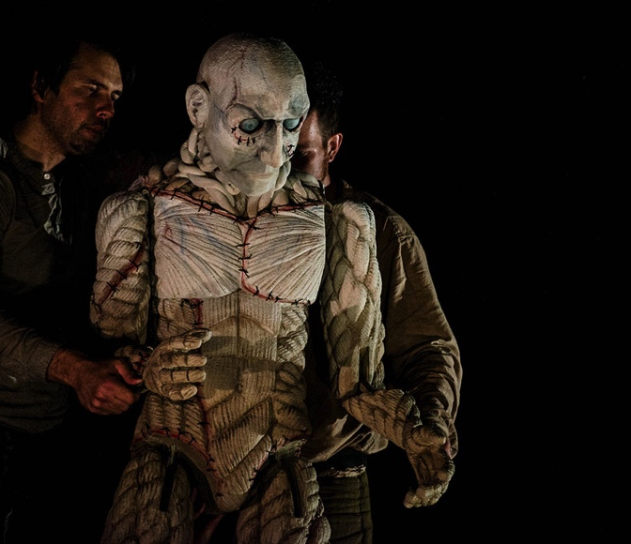  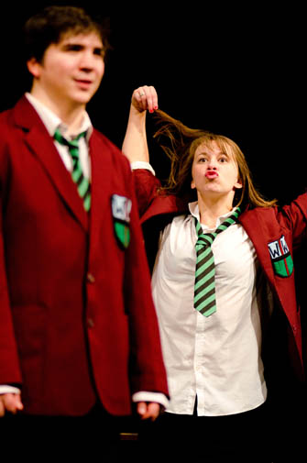  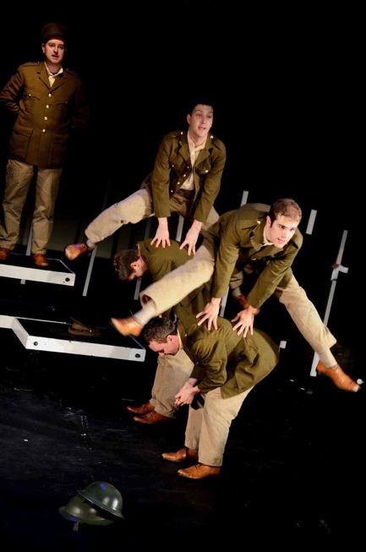
Images / Online Media / Contact Details

For local enquiries, please contact:  Adrian McDougall  Blackeyed Theatre  07766 681943  Adrian@blackeyedtheatre.co.uk  www.blackeyedtheatre.co.uk | For national enquiries, please contact:  Alex Shaw  Chloe Nelkin Consulting  020 7434 7204  alex@chloenelkinconsulting.com  info@chloenelkinconsulting.com

Marketing Materials
Download from:
https://www.dropbox.com/sh/9bed8p9bljk11k6/AAAppLMQU8GpFZ_XzbbrN3OWa?dl=0
Includes brochure images, production and press photos, education pack, E-shot images, Twitter/Facebook headers, logos, layered artwork.

Video Trailer:
Available from late September

Interviews: Cast and creatives are available for interviews from Tuesday 29 August.

Social media links:
Twitter page
https://twitter.com/Blackeyedtheatr
#jekyllandhydetour

Frankenstein Facebook group
TBC
Youtube playlist
http://www.youtube.com/playlist?list=PL1310ED26A6AADB80

Blackeyed Theatre Ltd
South Hill Park Arts Centre
Ringmead
Bracknell
Berkshire RG12 7PA
info@blackeyedtheatre.co.uk
www.blackeyedtheatre.co.uk

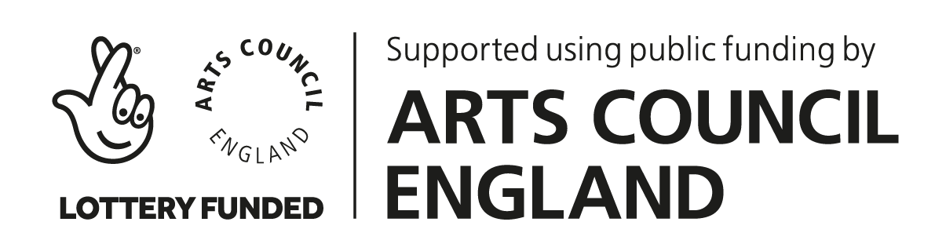 | 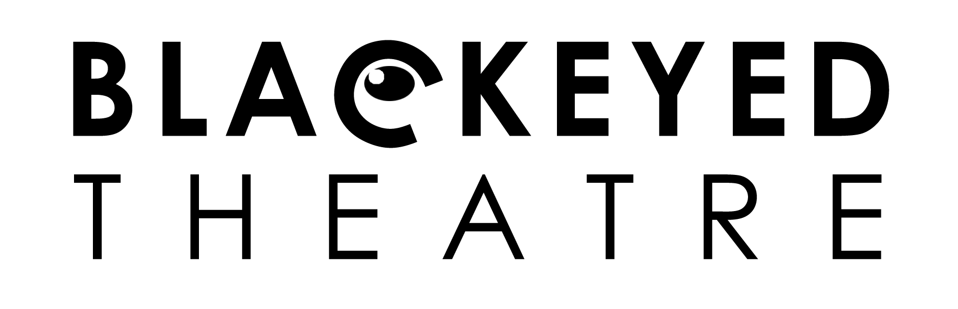 | 

